Sequence diagram – PregnancyBehaviour.getAction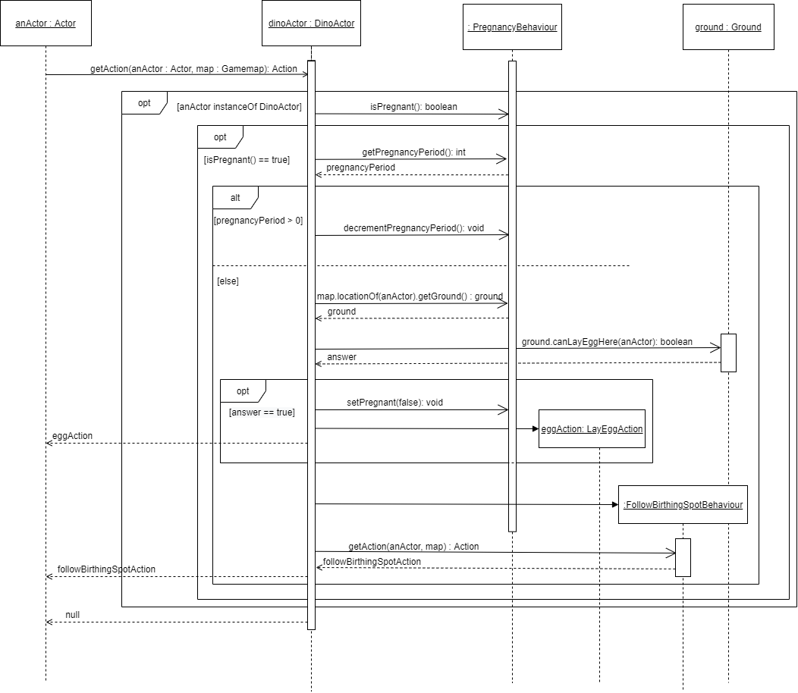

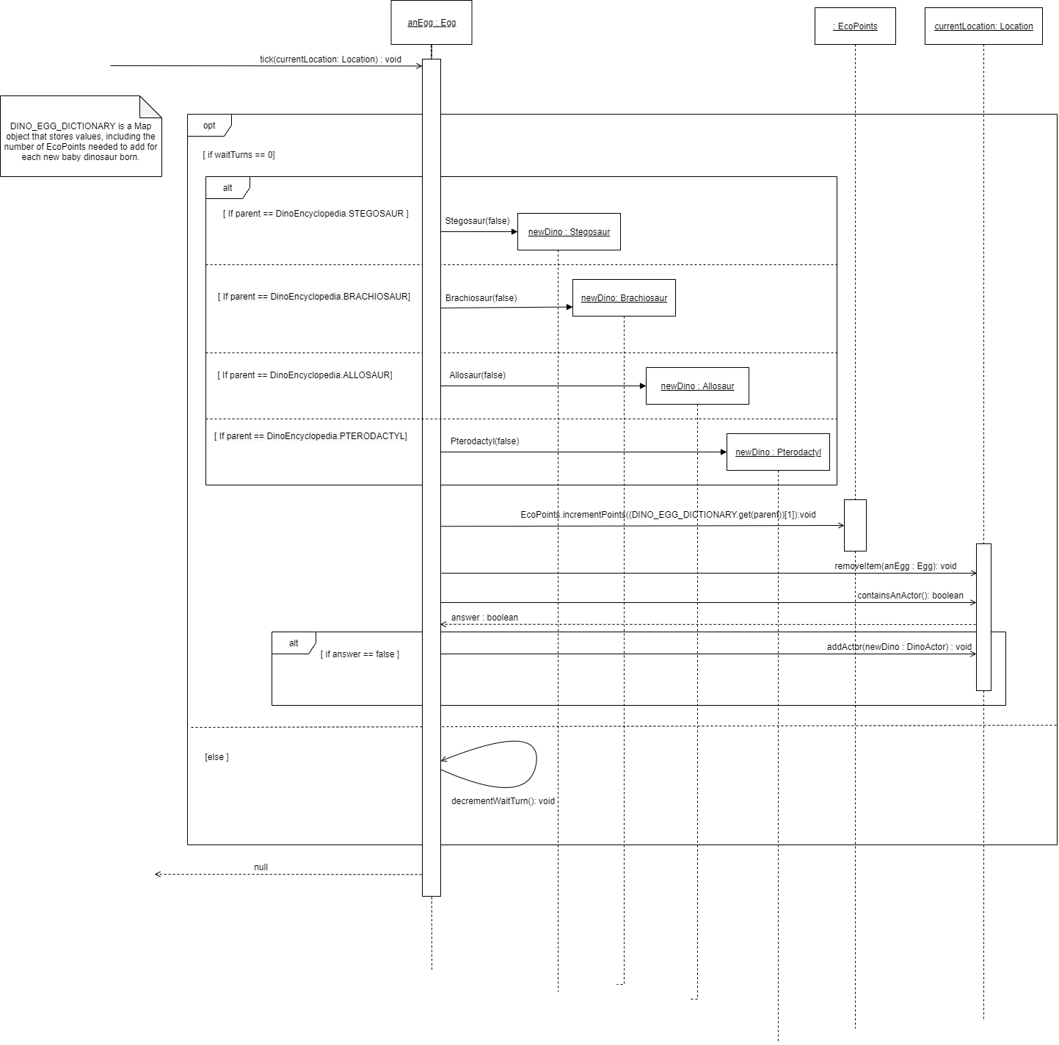Sequence diagram – Egg’s tick method

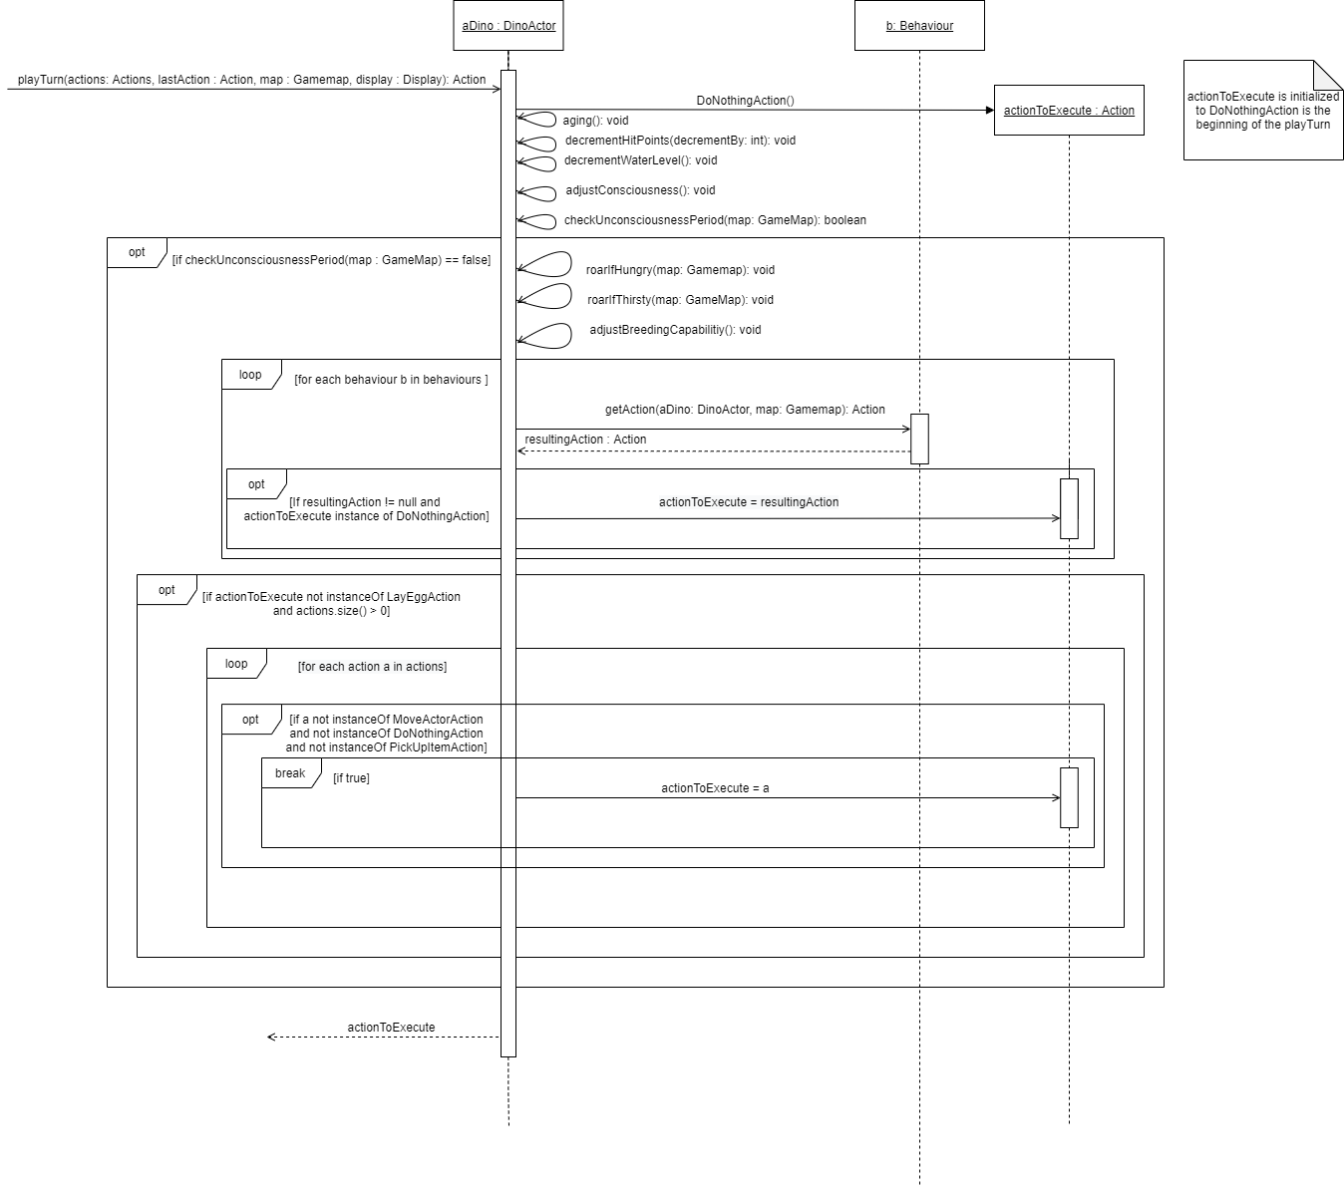Sequence diagram – DinoActor’s playTurn method

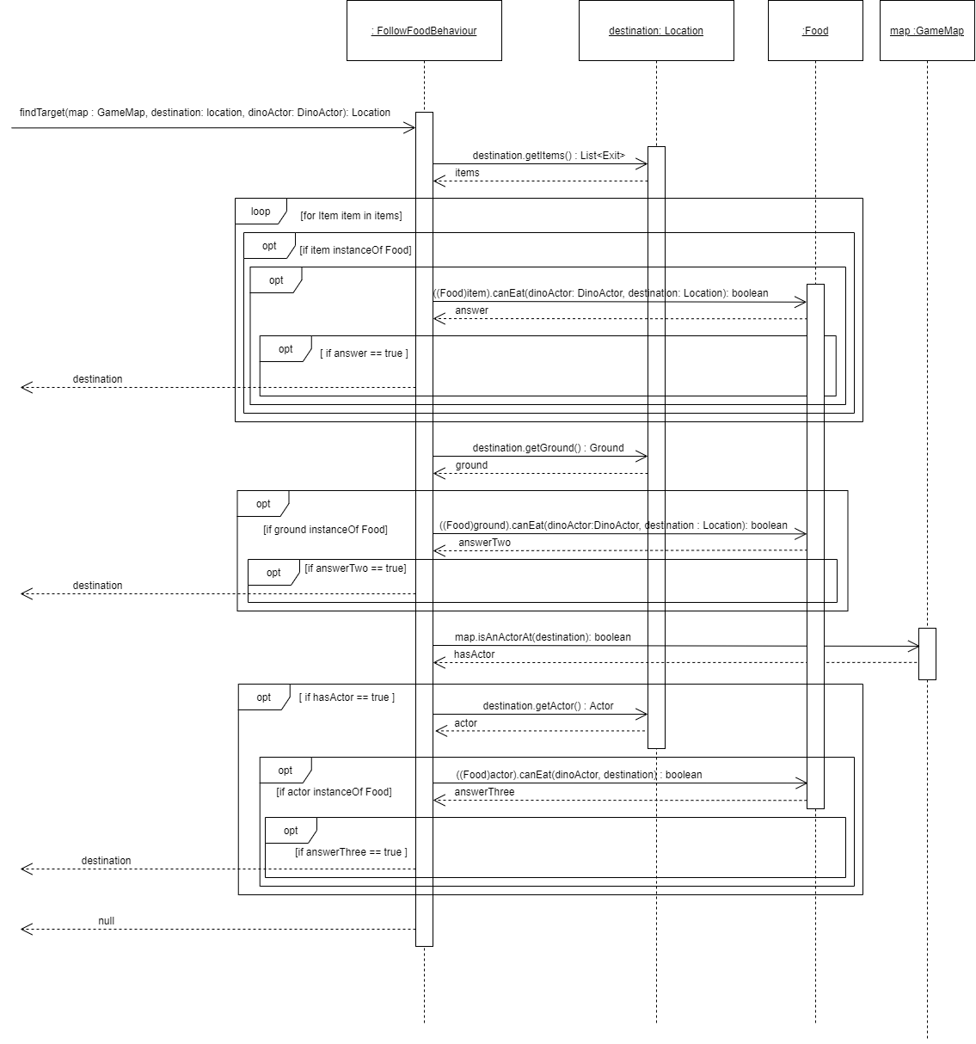Interaction diagram – FollowFoodBehaviour.getAction

Sequence diagram – PlayerFeedAction’s execute method

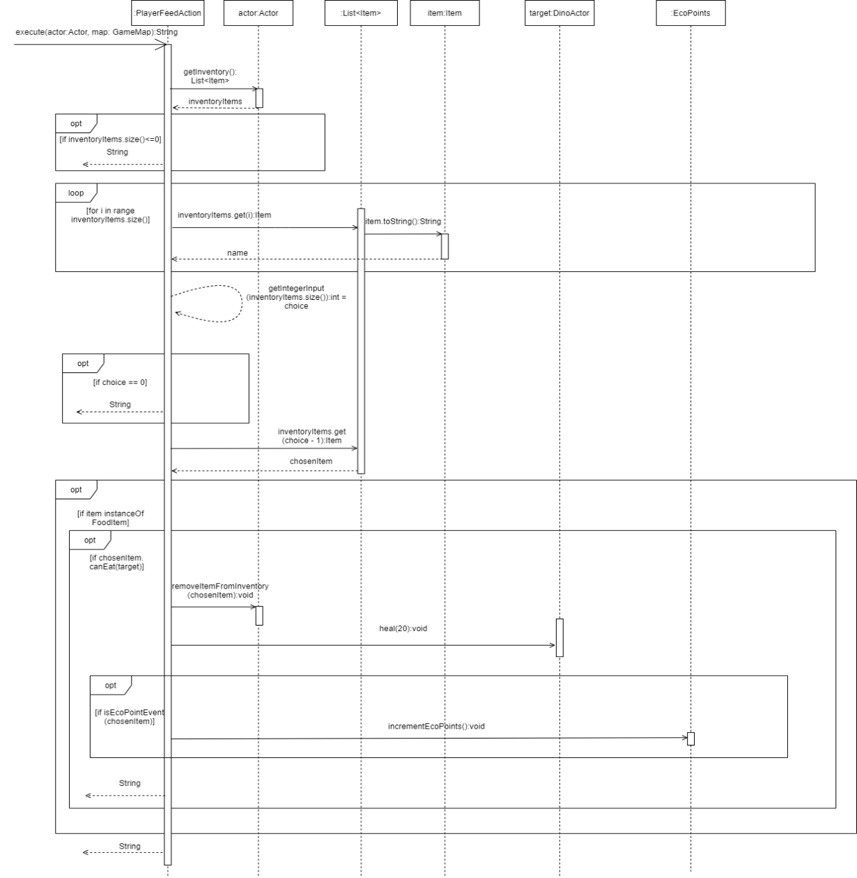

Sequence diagram – SearchItemAction’s execute method

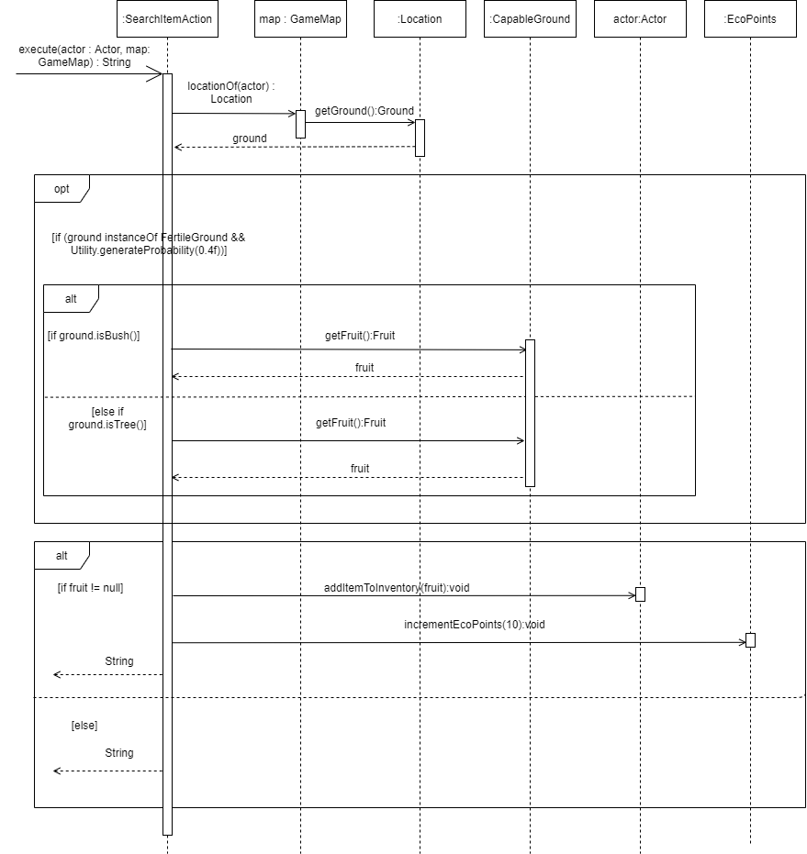

Sequence diagram – AttackAction.execute method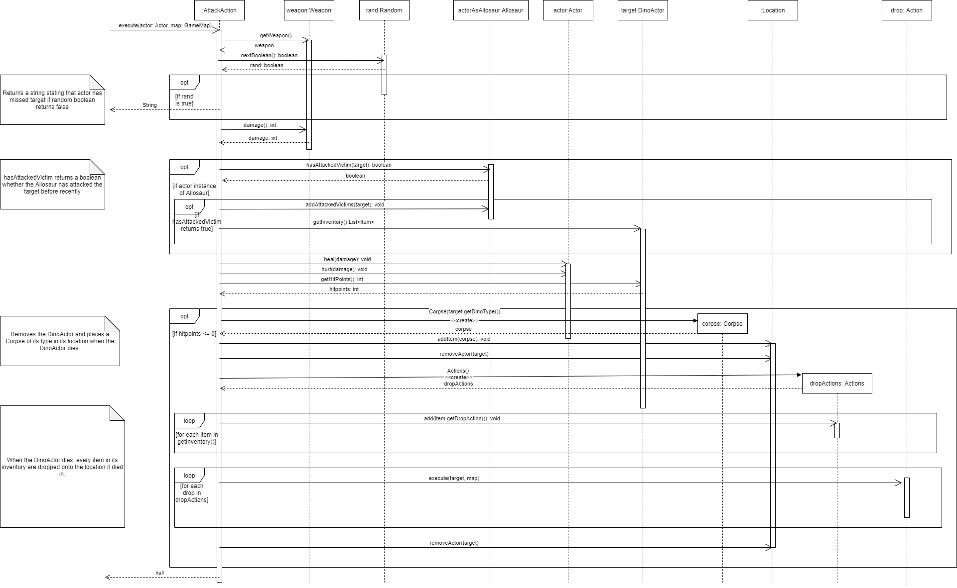

Sequence diagram – AttackBehaviour.getAction method

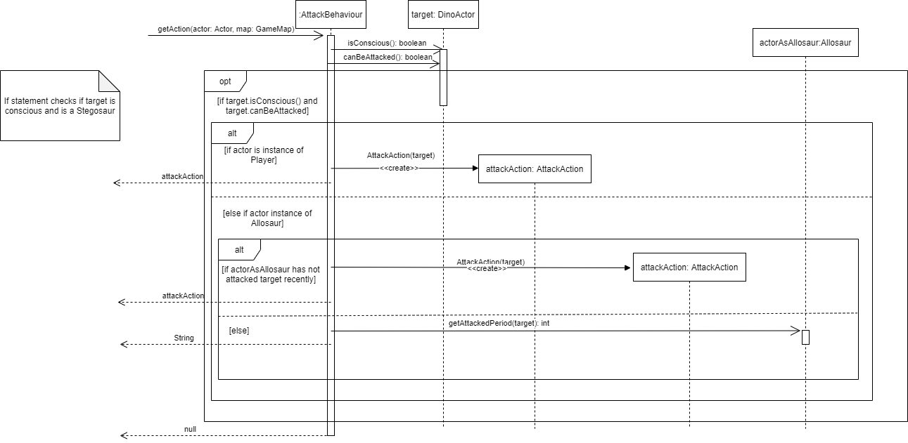

Sequence diagram – FeedingAction.execute method

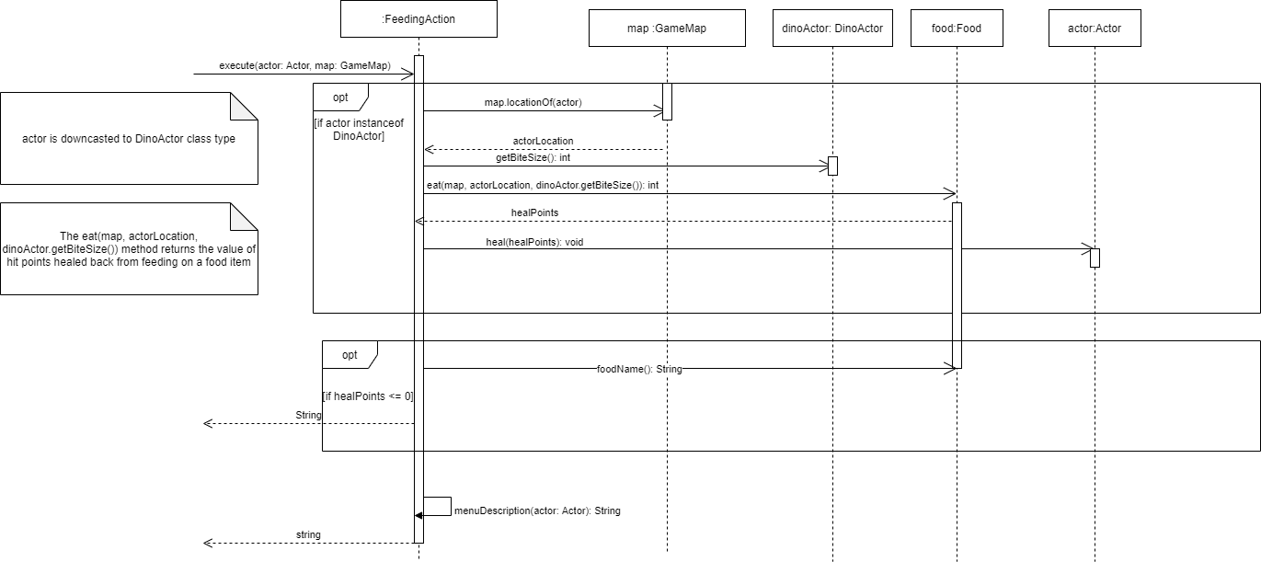

Sequence diagram –FeedOnActorBehaviour.getAction method

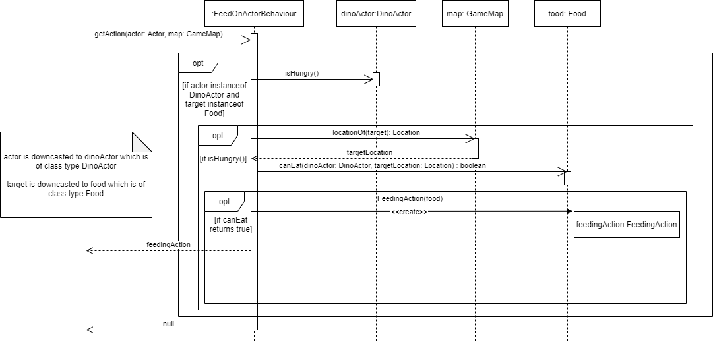

Sequence diagram – FeedOnItemBehaviour.getAction method

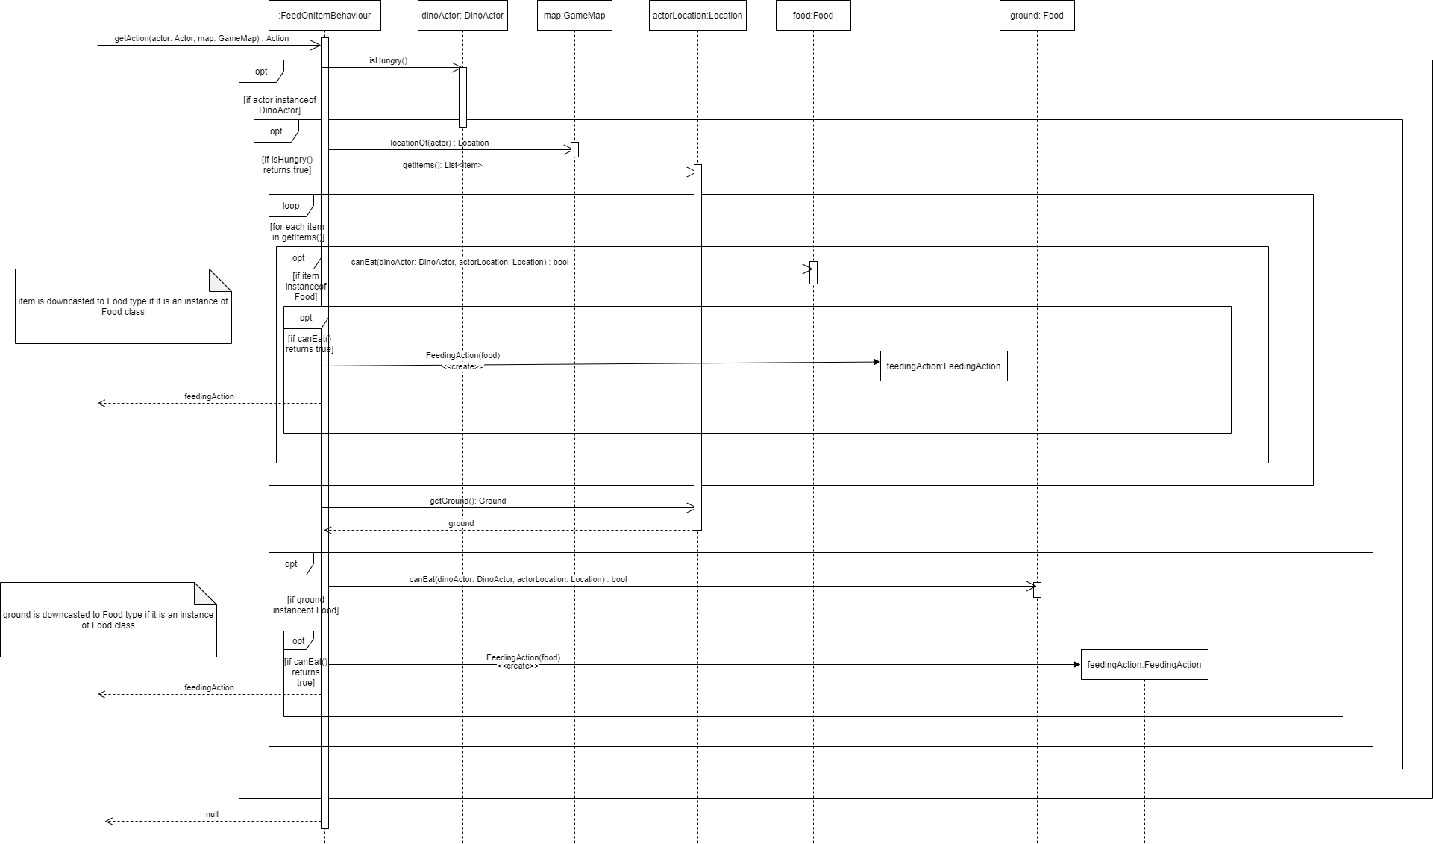

Sequence diagram –DrinkingAction.execute method

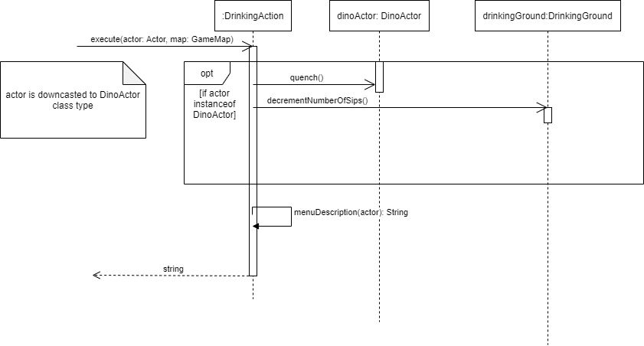

Sequence diagram – DrinkingBehaviour.getAction method

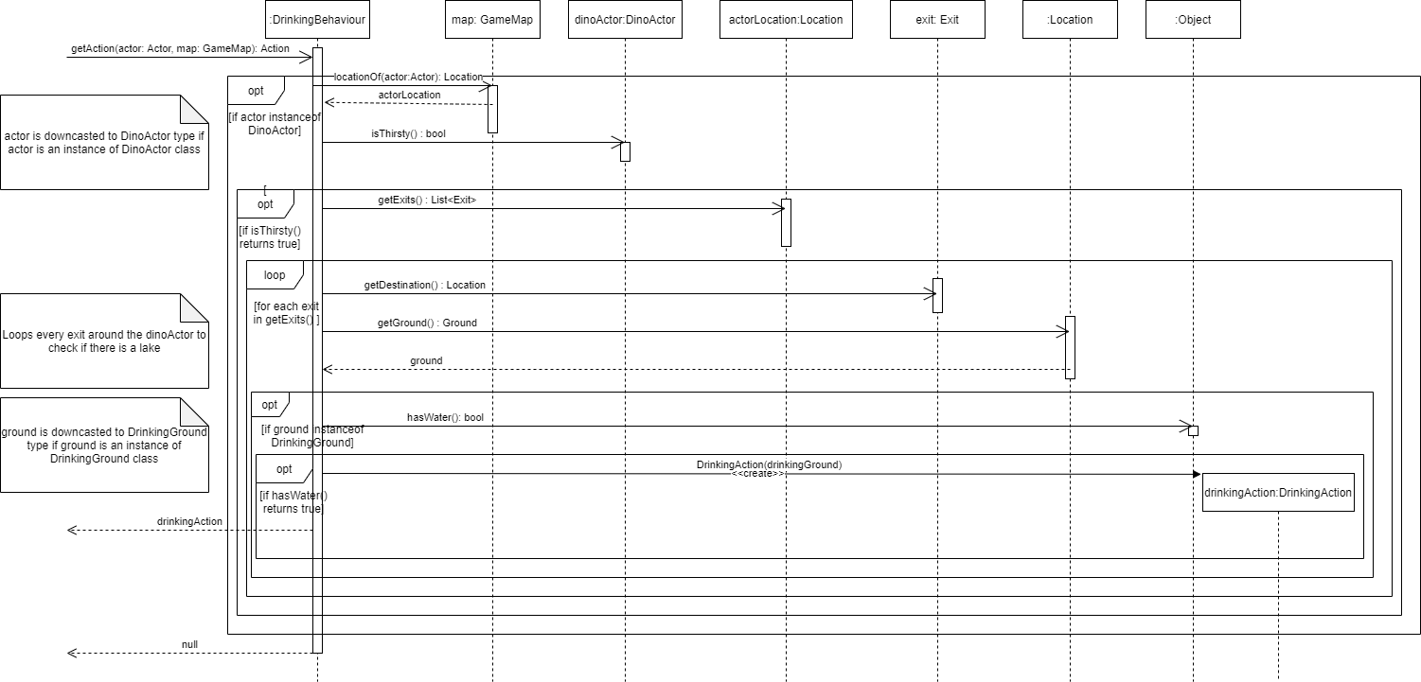

Sequence diagram – VendingMachine’s choose method

